**INTERNSHIP REPORT**

**ON**

## WEBSITE APPLICATION DESIGN AND

## DEVELOPMENT

**A report thesis for the partial fulfillment of the requirement for the award of**

**Degree**

**BACHELOR OF ENGINEERING**

**IN**

**INFORMATION TECHNOLOGY ENGINEERING**

Submitted by

**Mohd Moiz Uddin Zeeshan**

**1604-18-737-024**

**Under the guidance of**

**Dr.Mohammed Pasha**

**Senior Lecturer**



**DEPARTMENT OF INFORMATION TECHNOLOGY**

**MUFFAKHAM JAH COLLEGE OF ENGINEEREING AND TECHNOLOGY**

**(Affiliated to OSMANIA UNIVERSITY, Hyderabad)**

**Banjara Hills, Hyderabad**

**2020-2021**

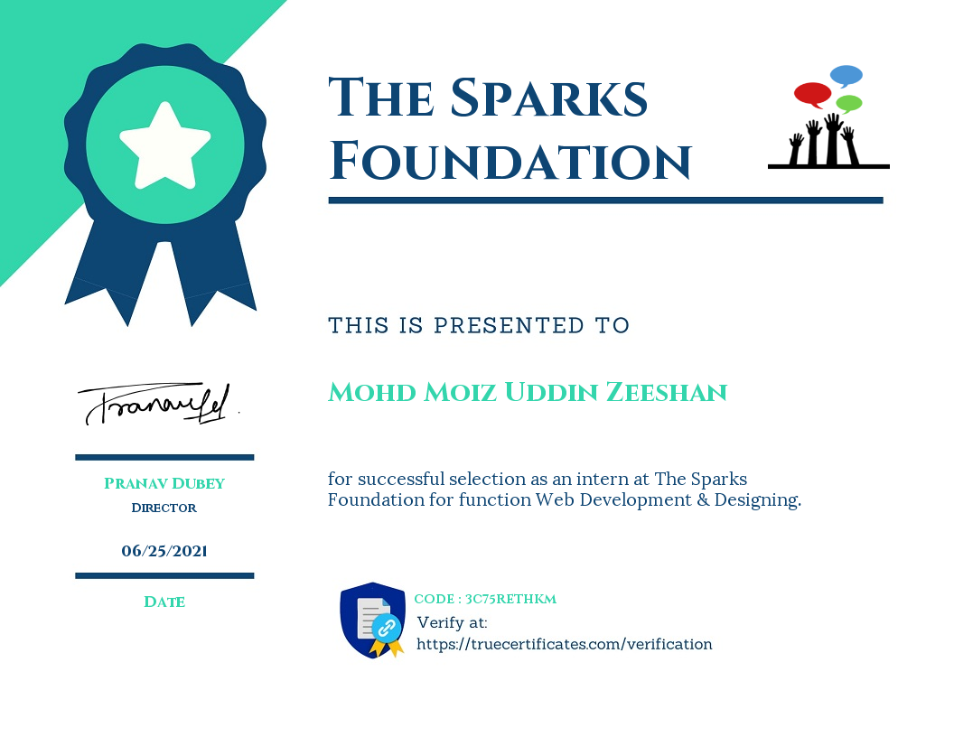

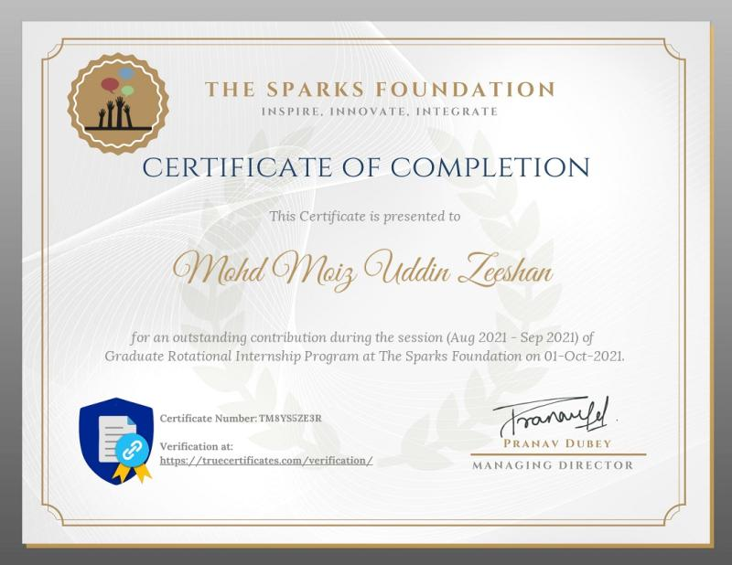

**ACKNOWLEDGEMENT**

Firstly, I impart and categorical gratitude almighty God for His divine blessings and giving me the strength to finish this project work spot with success. I really grateful and want our profound our Mohammed Pasha, Senior Lecturer, Department of IT, Muffakham Jah college Of Engineering and Technolgy, Hyderabad. Deep information and keen interest of my supervisor within the field of website application design and development influenced me to hold out this spot. His endless patience, studious steering, continual encouragement, constant and energetic oversight, constructive criticism, valuable recommendation, reading several inferior drafts and correcting them the least bit stage have created it attainable to finish this spot. I would wish to specific my heartiest feeling to Dr. Mousmi Ajay Chaurasia Professor and Head, Department of Information Technolgy and Engineering, for his kind facilitate to end my internship and conjointly to alternative faculty member and therefore the employees of Information Technology and engineering department of Muffakham Jah College Of Engineering and Technology. I would wish to impart my all course mates in Muffakham Jah College Of Engineering and Technology, who took half during this discuss whereas finishing the course work. Finally, I must acknowledge with due respect the constant support and encouragements of my parents throughout this internship.

**ABSTRACT**

The main objective of this internship was WEBSITE DESIGN AND DEVELOPMENT. Several programming languages that are in use to develop a web based application or software. Some of them are only used for the UI and the frontend of the application, some are used for the backend design of the software. For example- HTML3, HTML4, HTML5, CSS, Bootstrap Framework etc. are some programming languages to develop the frontend of an application. React,MongoDB,Angular etc are used at the backend. Nowadays there are also some framework&#39; s that use vastly. Frameworks are basically structured programming by using Model, View, and Controller. It is also called as MVC. If we develop web based application that is very useful for us because we can access it from anywhere of the world. It is very helpful for our daily life. That is why I choose subject of my report is WEBSITE DESIGN AND DEVELOPMENT. Working in The Sparks Foundation added huge experiences in my upcoming career. Solving real life problems was another key issue. This report takes us through all the details of WEBSITE DESIGN AND DEVELOPMENT knowledge and experience gathered during this internship period.

|  |  |  |
| --- | --- | --- |
|  | **TABLE OF CONTENTS** |  |
| **CONTENT**  Approval |  | **PAGE NO**  i |
| Declaration  Acknowledge |  | ii  iii |
| Abstract |  | iv |
| **CHAPTER** |  | **PAGE NO** |
| **CHAPTER 1: Introduction** |  | **4-6** |
| * 1.1 Objectives |  | 4 |
| * 1.2 Goals |  | 5 |
| * 1.3 Motivation |  | 5 |
| * 1.4 Report Layout |  | 6 |

CHAPTER 2: Internship Enterprise 7-8

* 2.1 About Company 7
* 2.2 Head Office 8

CHAPTER 3: INTERNSHIP ROLES AND RESPONSIBILITIES 9-18

* 3.1 Introduction 9
* 3.2 Training Attended 9
* 3.3 Assigned Responsibilities 9
* 3.4 Work Environment 10
* 3.5 Performed Tasks 10
* 3.6 Web page Details 11

CHAPTER 4: INTERNSHIP OUTCOMES 19-21

* 4.1 Problems and Solutions 19
  + 4.1.1 Problems 19
  + 4.1.2 Solutions 19
* 4.2 Learning Outcomes 20
  + 4.2.1 HTML 20
  + 4.2.2 CSS 20
  + 4.2.3 Bootstrap 20
  + 4.2.4 JavaScript 20
* 4.3 Challenges 21

**CHAPTER 5: CONCLUTION AND FUTURE SCOPE 22-23**

* + 5.1 Conclusion 22
  + 5.2 Future Scopes 22

## REFERENCE 24

|  |  |  |
| --- | --- | --- |
| **Figures** | **LIST OF FIGURES** | **PAGE NO** |
| Figure 3.6.1 Home page |  | 11 |
| Figure 3.6.2 Contact Us page |  | 14 |
| Figure 3.6.3 About Us page |  | 15 |
| Figure 3.6.4 Login page |  | 16 |
| Figure 3.6.5 Register page |  | 17 |
| Figure 3.6.6 Payment page |  | 18 |

* 1. **Objectives**

**CHAPTER 1: INTRODUCTION**

Internship is thought on addition a few encounters from the different a few associations which will encourage bounty to make a connection between the hypothetical and reasonable data. It includes profitable ability like usable working environment or pc instrumentation, taking care of a spread of things in the meantime, sorting out or dissecting learning, spending plans or rising collaboration, composing, and talking gifts. Usable work environment or pc instrumentation, composing, and talking gifts. It’s indispensable to get a handle on the best approach to impart data to outsiders, managers, and companions. While doing an undergraduate program in computer science and engineering at Muffakham Jah College of Engineering and Tecnology, I considered a few programming courses Last 4 years. Be that as it may, this is frequently not happy to get a handle on the web developing because of it's an extremely huge marketplace. to encourage a sound data concerning programming which has net application style and Development. I'm intrigued to attempt and do entry level position in The Sparks Foundation.

This entry level position report covers the whole temporary job time that I have finished with progress concerning the coding, style and improvement.

.

# Objectives

* + - Understand basic concept and structure of HTML3, HTML4, HTML5, CSS, Bootstrap Framework, React, JavaScript, creating Database & connecting with WordPress
    - To get awareness about the various job opportunities.
    - To perceive communicational skills and organizational dynamics.
    - To get educated about the official habitat.
    - Opportunities for technical skill.
    - Improve communication skill.
    - Knowing all type of official knowledge.

# Goals

* + - Knowing practical knowledge about programming.
    - Gain knowledge about HTML3, HTML4, HTML5, CSS, Bootstrap Framework, React, JavaScript,MongoDB etc.
    - Increase communication skill with other.
    - Gain essential background knowledge.
    - Works well with others.
    - Develop research skills.
    - Improve administrative skill.
    - Increase the capability for solving the problems.
    - Knowledge of professional journals and newsletters.
    - Knowledge of key professional.
    - Improve professional ethics and values.
    - Improve technical skill.

# Motivation

For internship to induce the sensible expertise within the field of technology and Engineering. It's extraordinarily vital that knowing about hypothetical information and actualize inside the reasonable field to broaden our gifted ability in building work advertise.

The motivation of this internship actually came from the intention of learning more about the job sectors and the work environment of IT farms. A desktop base system of creating websites is easy to learn. Before joining the internship, i knew that I am in a primary stage and beginner level in learning web development, my first task is to learn and create and be creative. The

learning curve of a web development is such interesting and charming. It is very simple to build a project fully by HTML, CSS, MYSQL and JavaScript when you know what you are doing.

# Layout of Report

This Layout contains key points of this report as like objective details of the kind of paper selected, the margins, line spacing, pagination, and equation illustrations, and references, incorporation. Table 1 presents general page layout specifications.

I may allocate a document format for each report that I make. Through the document design, I describe the report's template attributes, like the report's page format and report’s data's number format. I am able of setting parameters for the documents when I use the functions of layout.

Once I define a document format, I explicitly specify a design for a report and I can modify a report's default layout.

* + - **Chapter 1** Describes the details of introduction of web development.
      * Objective. In this portion, the objective of the internship is described. It also consists of the facility, resources, how to reduce the number of employees and load of work on them. How to implement, inheriting the motivational thinking of web development.
      * Goals. Goals describes the aim of the internship. The key features of this part is to analyze the learning by the internship. It also shows the effectiveness and the choices can be made in future.
      * Report layout. It is a overview of the chapters contain in the full report.
    - **Chapter 2** This chapter is dedicated to describe the company I am doing the internship in. The motto and the goal of the company is stated in this chapter.
    - **Chapter 3** This chapter consists of the responsibilities and the roles I was given while doing the internship. This contains the training attended, work environment, assigned roles and responsibilities and the performed tasks.
    - **Chapter 4** This chapter contains the outcomes of a project and as well the internship. The outcome of a project is the result, and the problems and their solutions. For example understanding OOP and learning about the challenges and outcomes.
    - In the **Chapter 5** This chapter simply contains and describes the conclusion of the report.

# CHAPTER 2 ENTERPRISE OF THE INTERNSHIP

* 1. **Company information**

The sparks foundation is working to bring parity in education, making sure children have equal opportunity at success, irrespective of the financial background.

### Our Vision Statement

A world of enabled and connected little minds, building future.

### Our Mission Statement

#### Statement

To inspire students, help them innovate and let them integrate to build the next generation humankind.

#### Inspire

To inspire, motivate and encourage students to learn, create and help build a better society.

#### Innovate

To teach new ways of thinking, to innovate and solve the problems on their own.

#### Integrate

To let the students integrate, and help each other, learn from each other and do well together.

The Sparks Foundation also give many services like

* + - Software development.
    - Software Development Kit
    - Website development.
    - Mobile app development.
    - CRM
    - Inventory management
    - Analytic, Reporting and Big Data solutions
    - Dedicated Support Team
    - Value Added Service Design & Implementation

# Head Office

Name : The Sparks Foundation

Address : The Hangar, I-Cube, 21 Heng Mui Keng Terrace, Singapore 119613

+65-8402-8590

[info@thesparkfoundatio.sg](mailto:info@thesparkfoundatio.sg)

## Languages of Technologies

ASP.NET, JAVA, PHP, Perl, C++, JavaScript, XHTML, React, JavaScript, CSS,

## Databases Systems

MySQL, MongoDB

## Server Platforms

Linux, Mac OS X and Windows table with the new website layout and would recommend Bengal Solutions to anyone.

## Frameworks

BootStrap

# CHAPTER 3

**ROLES AND RESPONSIBILITY OF THE INTERNSHIP**

# Introduction :

This chapter secured the approach of internship program and gives the data about Where internship has been connected to accept accountability this program.

# Training Attended

We know that there are many languages and skills needed to build a project, i used all the languages like JavaScript, React, C++, HTML, C and more. The server combines the result and execute PHP codes containing various form of data like Image, Text etc. HTML code can also be implemented using a command-line interface (CLI) is used to apply the independent applications for graphical use. The training that I underwent at The Sparks Foundation. is show below:

* + - JQuery
    - HTML5, HTML4
    - JavaScript
    - CSS3, CSS2
    - MySQL
    - Bootstrap

# Delegated Responsibilities:

* + - UI/UX design.

Designing UI/UX for Websites and Mobile applications.

* + - Web design. Designing websites.
    - Frontend development.

Developing the frontend of various websites.

* + - Android app development.

Designing and developing Android applications.

# Environment of Work

**Frontend Developer** The main job of a frontend developer is to work at the client side designing web pages and graphics that is s accessible by the user.

**Backend Developer** The responsibility of a back end developer is to develop the rear end of a website that interacts with the server. This type of web developer specializes in the languages like HTML, ruby, ASP.Net, Java, Cold Fusion, and Perl [6].

The job profiles for the web developer includes:

* + - Frontend web developer.
    - Backend web developer.
    - Developer of web applications
    - Analyst for Design and layout Analyst for.
    - Senior web analyst.
    - Web marketing analyst.

# Performed Tasks

The name of the project is the design and implementation of the Online Shopping E- Commerce Website. An online store is a web-based virtual store where customers can browse the catalog and select interesting products. The selected items will be gathered in shopping cart. The items will be presented as an order when the customer wants to check out from the site. This time the website will ask for more information for the transaction. The customer will fill a billing from containing billing address, shipping address, options for shipping and his or her payment information like credit card number. The customer will receive an e-mail notification when the order is placed [4].

# Web Pages details

* Home
* About Us
* Donate now
* Contact Us
* Login
* The Sparks Foundation

## Home Page:

In this page the home screen of the website is showed. Users can surf through this page to access all the features the website contains. The overview the website is also present in this page.

Figure 3.6.1 shows the home page

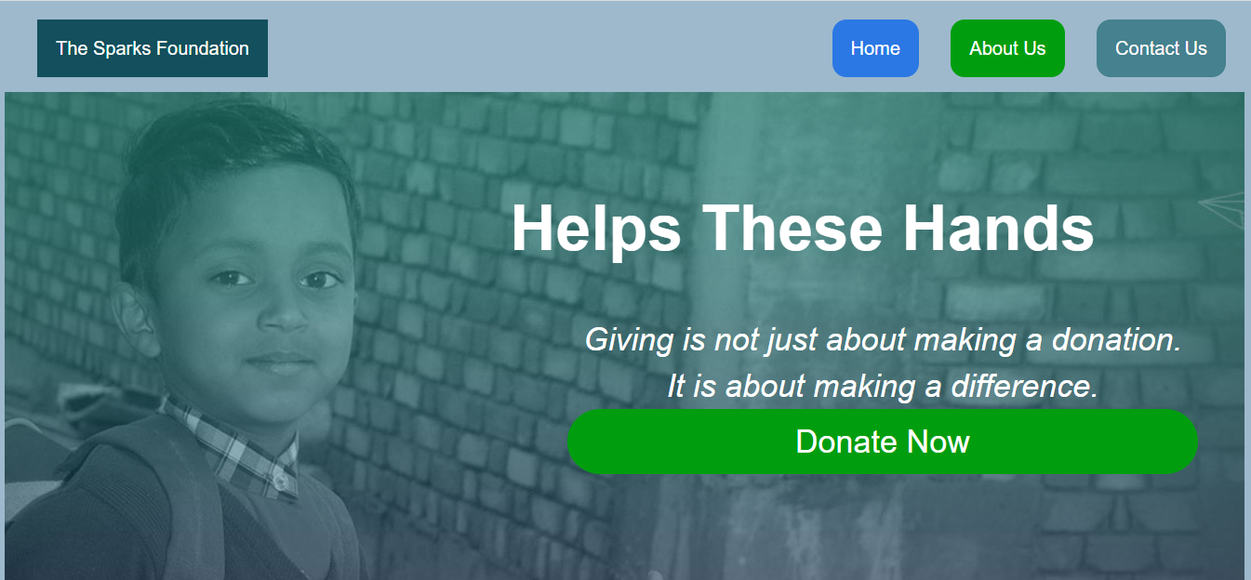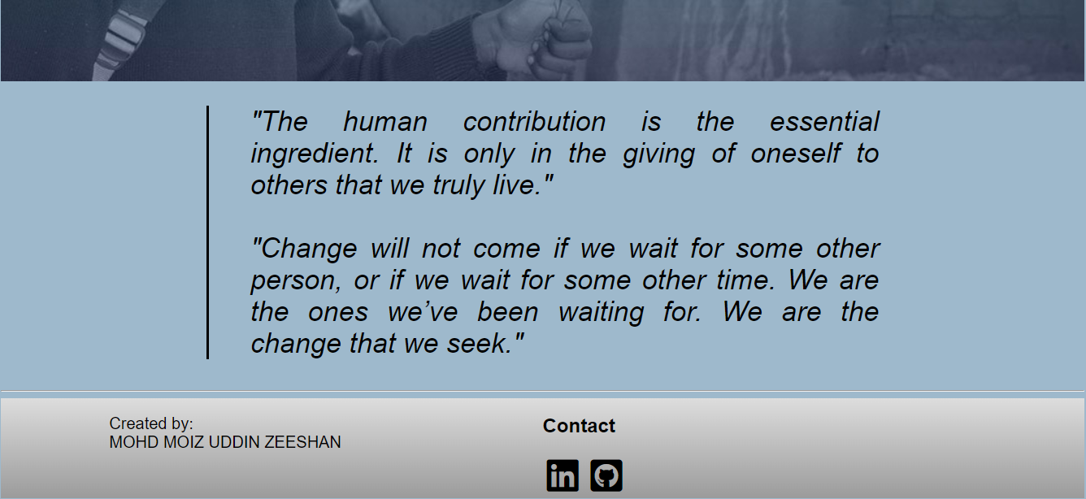

## Sparks Foundation Page

This page contains all the details about the sparks doundation. This is the information page. Either registered or non-registered users can access this page.

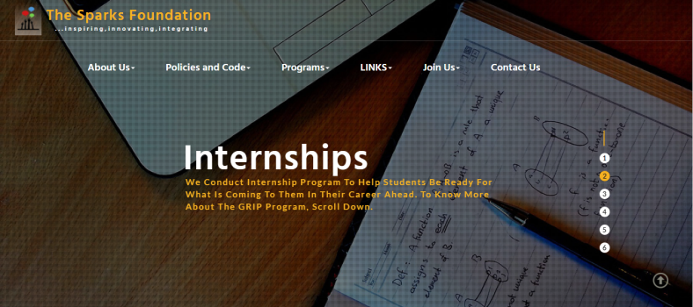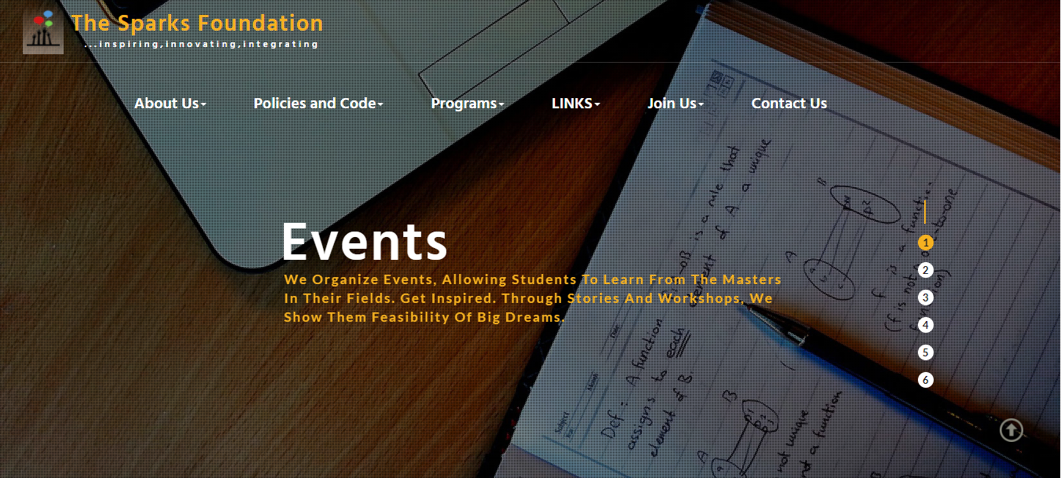

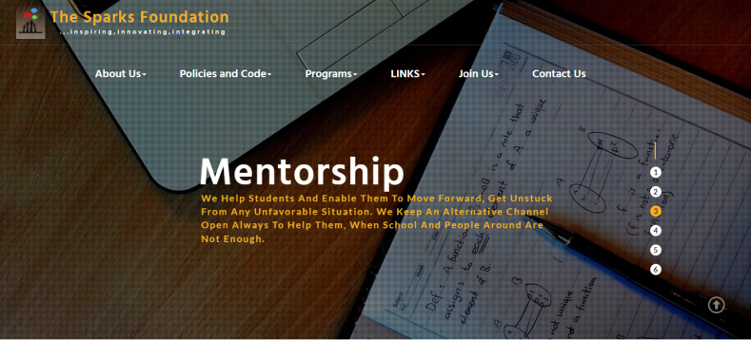



## Contact Us Page:

This page is dedicated to all the info needed by the customer and consumers to contact the administrators of the web page. Figure 3.6.4 shows the contact us page.

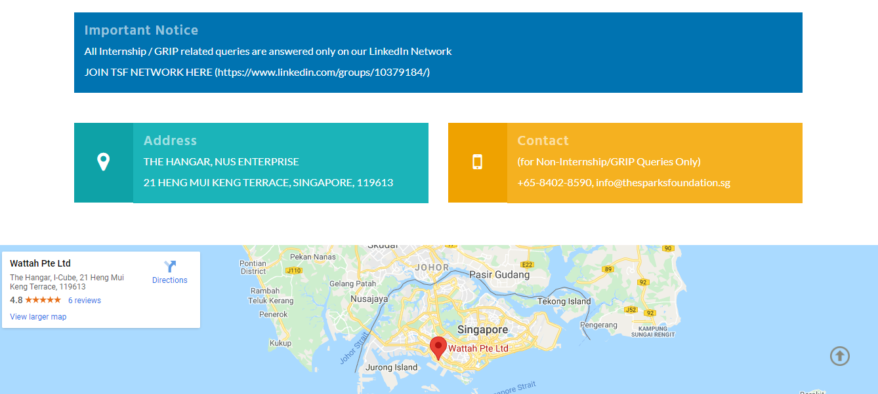

Contract us page

## About Us Page:

This page is dedicated to the goals and aim of the foundation. It also tell why the company was founded and what other services they offer.

Figure 3.6.5 shows the about us page.

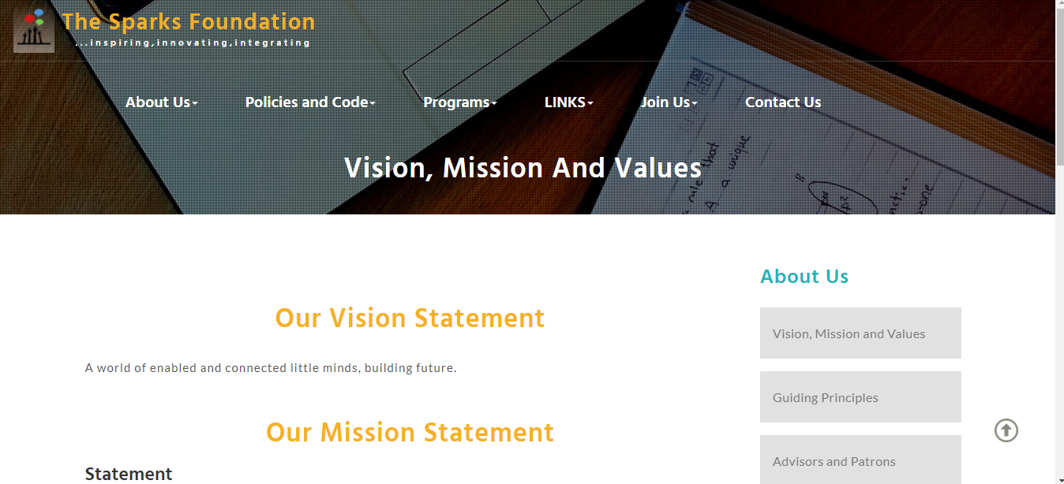

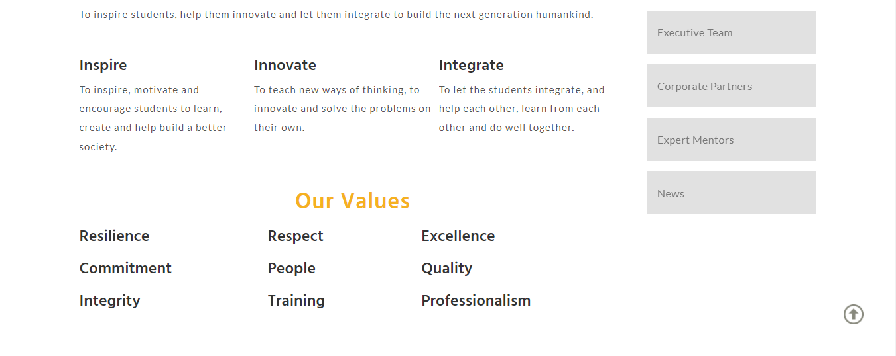

About Us

## Login:

This page can be accessed by both user and admin to login to the site. shows the login.



Login page

## Sign-up Page :

This is the sign-up page. This gives the chance to new user to sign-up as a registered customer. shows the sign-up page.

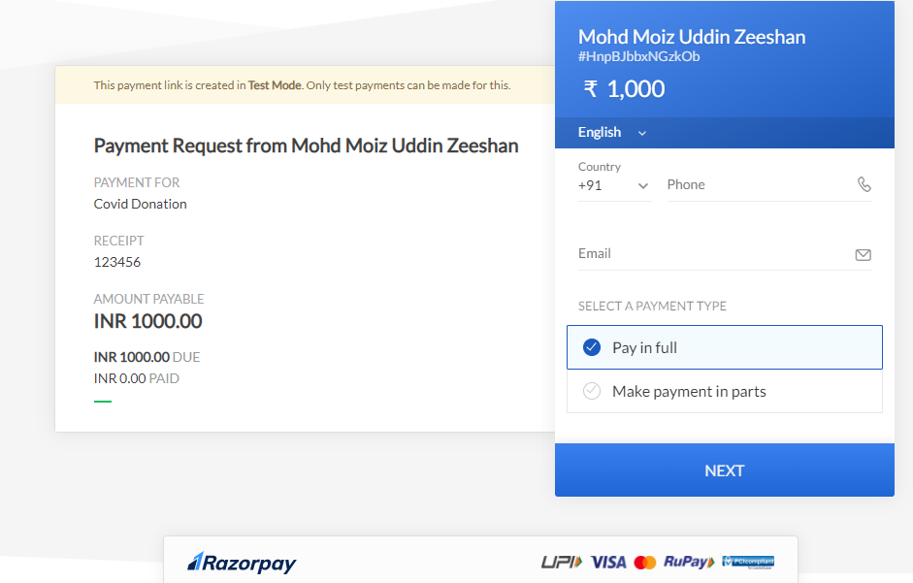

Sign-up Page

## Payment Page:

This page appears when the customer wants the check out. In this page the order summary is presented and the customer needs to fill up payment information to proceed . Figure 3.6.8 shows the payment page.

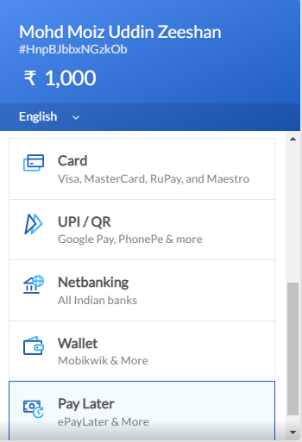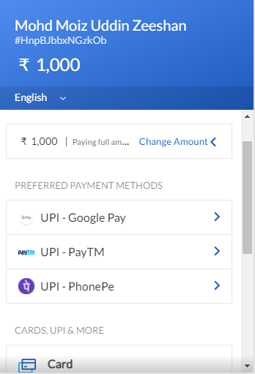

# CHAPTER 4 INTERNSHIP OUTCOMES

* 1. **Problems and their Solutions**

Issues based on development can be faced as the result it requires more vocabulary of form markups, methods, objects, modifiers, and many ways to build software or plan. And it's not just web development issues that have more solution that can be easy and quick.

# Problems

I faced so many problems to create while working with CSS. It's very easy, but sometimes it doesn't match my expectations and is placed in the right place. Web design is not a simple task. To come up with a unique web design it takes a lot of creativity, brainstorming, cooperation of the group and uniqueness. A web designer goes through a lot of obstacles in regular basis. Only the web designs that were in the process of constant development and recursive thinking can satisfy the target market and clients. This creates a challenging environment for designing websites.

On the opposite, web designers face some other obstacles. Such tasks include maintaining a website that is sensitive enough to be viewed and accessed on all phones. Websites sometimes take time to load, so making website loading faster is one of the toughest challenges for web design to provide a better user experience.

There is another issue that happens most often. Clients face issues with the website and complain it to the developer. But when developers check the website it look absolutely fine to them. These issues can be caused by out dated web servers or when clients make incorrect changes to them. Finding the sources of these issues can be time consuming and developer had to tackle this in a daily basis.

# Solutions

Web development really is so fascinating and at the same time tough to me, I will learn and understand several goals with interest through internship training as if after studying I could understand web development and it is so interesting then all the other languages to me. During my training period, I solved the CSS and other problems. Clean software eliminates unforeseen errors that can impact the load of site. Automated website monitoring solutions frequently enable developers to view the websites of their customers in real time and set alerts to notify them when potential issues arise. Not only does this allow developers to recognise an issue before the customer does it, it also gives them the opportunity to address it in many situations before the problem affects the business of the customer.

# Outcomes of Learning

## HTML

* + - * **Basic HTML (Tags**, Element, Attributes, Paragraphs, Headings, Line Breaks, Horizontal Rule, Lists, Table, Color Codes, Font, Text Linking, Email, Images, Background, Comments, Meta, Media, Charset**)**
      * **Basic concept** (WWW& HTTP, HTTPS, Client Server Communication**)**
      * **HTML Forms** (Input**,** Text Fields, Password, Checkbox, Combo Box, Radio, Text Areas, Files, Buttons**)**
      * HTML5 features

## CSS

* + - * Basic CSS (selector, internal, external, Inline, Class, Id, Background, font, Text, Padding, Margin, Border, list CSS, hovering and elements)
      * Advance CSS (border-radius, opacity, cursor, layers, position, display, float, gradient, and multiple-column)
      * Concept of Menus (single menu, dropdown menu)
      * Template, design using CSS div.

## Bootstrap

* + - * Environment Setup
      * Grid System
      * Typography
      * Tables, Forms, Buttons, Images
      * Drop down, Button group
      * Navigation Element
      * Bootstrap plug-ins (Transition, Modal, Drop down, Tab, Tool tip, Alert, Button)

## JavaScript

* + - * Basic JavaScript (Syntax, Enable, Location, Operators, Variables, Events, Alert, Confirm, Prompt, POP up, Date, print)
      * JavaScript String (Strings, Length, Split, Search, Replace)
      * JavaScript advanced (get Element by Id, Inner HTML, Get table, index, DOM, manipulation, Regular Expression)

## PHP BASIC

* + - * Control Structures (if, else, else if, while, do-while, for, for each, break, continue, switch)
      * Include (require, include, require_ once, include_ once)
      * Function (User-defined Function, Function arguments, returning values, variables function)
      * Array (array declaration, merging, sorting, deleting, inserting)

# Challenges

During the design of the code, different types of problems have to be met. Also widespread:

* Syntax error.
* Fatal error.
* Find out the problem and try to solve that.
  + - * Basic JavaScript (Syntax, Enable, Location, Operators, Variables, Events, Alert, Confirm, Prompt, POP up, Date, print)
      * JavaScript String (Strings, Length, Split, Search, Replace)
      * JavaScript advanced (get Element by Id, Inner HTML, Get table, index, DOM, manipulation, Regular Expression)

## PHP BASIC

* + - * Control Structures (if, else, else if, while, do-while, for, for each, break, continue, switch)
      * Include (require, include, require_ once, include_ once)
      * Function (User-defined Function, Function arguments, returning values, variables function)
      * Array (array declaration, merging, sorting, deleting, inserting)

# Challenges

During the design of the code, different types of problems have to be met. Also widespread:

* Syntax error.
* Fatal error.
* Find out the problem and try to solve that.

# CHAPTER 5 CONCLUTION AND THE FUTURE SCOPE

* 1. **Conclusion**

As we all know, our country is a developing country and it dreams to be a developed country soon. Hence the government of Bangladesh has taken many necessary project to fulfilling the concept of digital Bangladesh. Day by day our job sector is getting more and more competitive. As a result every other company is searching for experienced candidates.

Finally, I can claim it's internship that helps me gain experience. Thanks to The Sparks Foundation, I gained so much more in-depth knowledge of technical skills and personal skills This project helped me gather theoretical and practical knowledge about HTML4/5, CSS, PHP, MYSQL and other programming language. Beforehand I was confident about designing and developing frontend of websites. Now I am also confident and competent in backbends.

For those students who are willing to work in web development, there are huge opportunities available. To give them the scope for online work and development of website, most private and public organizations employ web designers. With the rapid emergence of the digital industry, web development professionals ' demand is growing, and in the coming days this has already availed so many job opportunity for newcomers.

My internship company gave me a good scope to learn and discover my potentials. I am very grateful to them. Now I am able to develop web and mobile applications. I was fortunate for getting the chance to meet the real life software development environment.

# Future Scopes

I gained so much experience from this Internship. If I did not had this experience it would be very hard for me to find a suitable job. As we know finding work can be a challenge in this competitive world. In my career opportunity, this internship will support me. And my future scopes will be after a good internship:

* + - I can work in an IT farm.
    - Working as a software engineer is possible.
    - Can persue career in web design.
    - Woking as a web developer is a possibility.
    - Can persue Mobile app developing.
    - Can work as a QA Tester.

# REFERENCE

* 1. <https://docs.newgenpayments.com/#/Payment-API>
  2. <https://payu.in/blog/update-alert-improved-payment-gateway-integration-guide/>
  3. <https://developers.google.com/pay/api/web/guides/tutorial>
  4. <https://razorpay.com/payment-gateway/?utm_adgroup=pg_payments_skag&utm_gclid=Cj0KCQiAw9qOBhC-ARIsAG-rdn6zCIYpBbIbnJWQFRStVQfpHCZxbHa-PcYtEPAKbC_F5t_jxrz4kksaAiKSEALw_wcB&utm_source=google&utm_medium=cpc&utm_campaign=pg_payments&utm_term=payment%20gateway&utm_content=responsive&hsa_ad=353210276636&hsa_tgt=kwd-11422011&hsa_acc=9786800965&hsa_grp=70698350825&hsa_src=g&hsa_ver=3&hsa_net=adwords&hsa_mt=p&hsa_kw=payment%20gateway&hsa_cam=1995263207&gclid=Cj0KCQiAw9qOBhC-ARIsAG-rdn6zCIYpBbIbnJWQFRStVQfpHCZxbHa-PcYtEPAKbC_F5t_jxrz4kksaAiKSEALw_wcB>
  5. <https://www.quora.com/What-is-Payment-Gateway-API>
  6. <https://www.integratepayments.com/payment-gateway/direct-post-payment-gateway-api>
  7. <https://www.youtube.com/watch?v=3JluqTojuME>
  8. <https://www.youtube.com/watch?v=Q33KBiDriJY>